TASK 5

Get all user details view: Retrieves and displays details of all users

Retrieves and displays details of a specific user based on their name .

Update User details

After using patch, retrieves all the data to see if patch worked

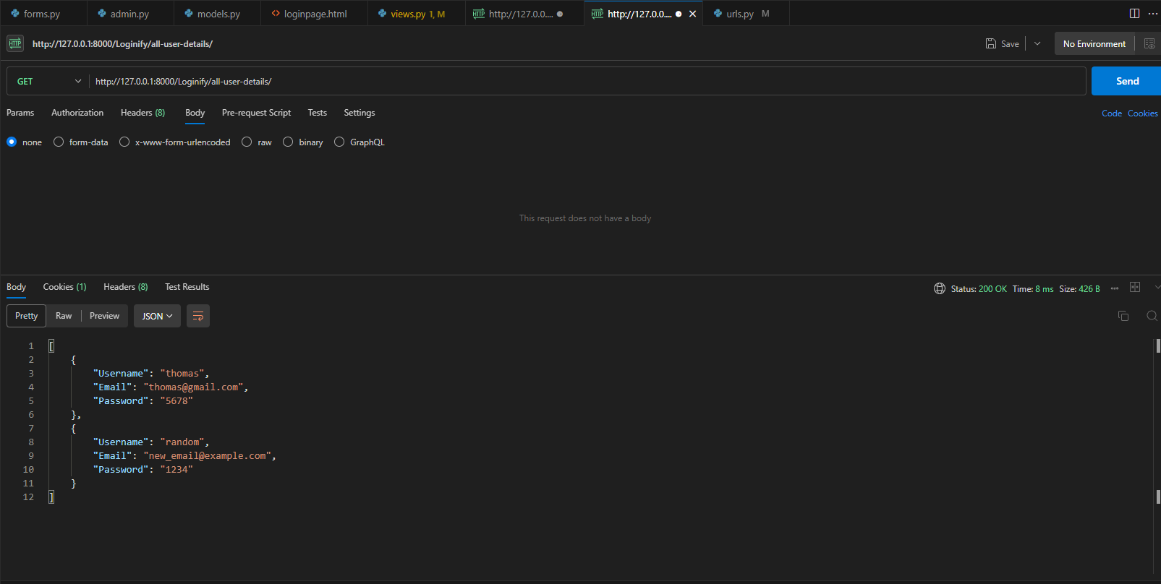

To delete a user using its email.

